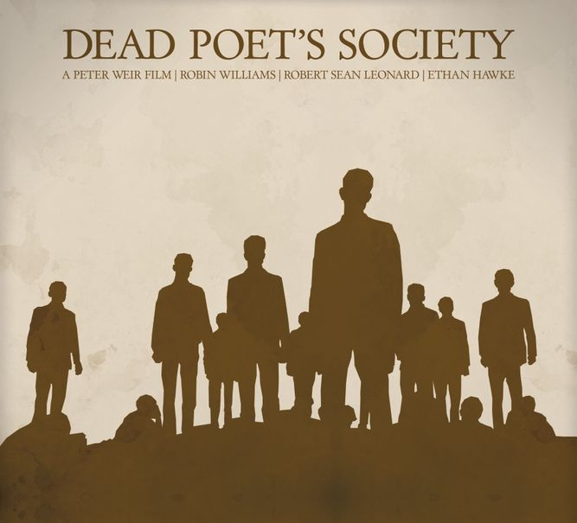
Dead Poets Society
5B English
Part 3, Monday 22nd of December

1. Choose the correct word (A, B, C or D) for each gap.
Sentence | Options
1. "I've made great ______ to get you here, Neil." | A) efforts B) sacrifices  C) attempts D) struggles
2. "Welton can forgive, provided you have the courage to ______ your mistakes." | A) accept B) admit C) confess  D) recognize
3. "Let him suffer the ______." | A) results B) outcomes C) effects  D) consequences
4. "You just signed your ______ papers, Nuwanda." | A) dismissal B) expulsion C) removal  D) exclusion
5. "Your reprimand made quite an ______, I'm sure." | A) scene B) impression C) effect  D) influence
6. "I intend to conduct a thorough ______ into this matter." | A) search B) inquiry C) study D) review
8. "Your complete ______ is expected." | A) cooperation B) collaboration  C) participation D) contribution

2. Choose the correct word from the box for each gap (1-12).
There are TWO extra words you do not need.
ashamed | betrayed | bold | deceived | defied | impressionable | obsession | reckless | scapegoat | self-destructive | blaming | tragic | unauthorized | whim
Nolan addresses the school about an (1)_________________ article demanding girls be admitted to Welton. He warns the teachers that boys their age are very (2)__________________. Meanwhile, Neil has (3)__________________ his father by secretly acting in the play. Mr. Perry is furious – he feels Neil has (4)_________________ him. He tells Neil that acting is just a (5)___________________ and not a serious career. Keating warns Neil that hiding his true feelings from his father is (6)__________________. But Neil cannot stop. After the (7)__________________ events at the end of the movie, Nolan demands answers. Cameron (8)______________ the group to save himself by signing a paper (9)_____________________ Mr. Keating. Keating becomes the (10)___________________ for what happened. The boys who signed feel too (11)____________________ to look at one another. In the final scene, Keating tells them: "Be (12)_____________________.

3. Change the word in CAPITALS to complete each sentence.
Sentence | Base Word
1."When you are ready to make your ___________________ to the school, let me know." | APOLOGIZE
2. "...provided you have the _______________________ to admit your mistakes." | COURAGEOUS
3. Neil felt _______________________ when his father dragged him off stage. | HUMILIATE
4. They said Keating could not avoid _______________________ for what happened. | RESPONSIBLE
5. Neil was _______________________ about acting because it meant everything to him. | PASSION
6. Neil's _______________________ led to a confrontation with his father. | DISOBEY
7. Keating's lesson in the courtyard was about the evils of _______________________. | CONFORM
8. Charlie's _______________________ behavior got him expelled from school. | REBELLION
9. Keating was an _______________________ to his students. | INSPIRE

4. Fill in the ONE missing word.
Sentence
1. "You will not let me __________."
2. Todd decided to stand __________ for what he believed in.
3. Cameron ratted on the group __________ order to save himself.
4. The boys were too ashamed to look __________ one another.
5. Keating told Todd to believe __________ himself.
6. Nolan conducted an inquiry __________ the matter.
7. Keating became the scapegoat __________ the tragic events at the end of the movie.
8. Mr. Perry made great sacrifices __________ Neil's future.
9. Charlie got __________ trouble for his phone prank.
10. The boys had to suffer the consequences __________ their actions.

5. Writing Task: Blog Post
Write a blog post (150-180 words) on ONE of the following topics.
Option | Topic
A | Conformity vs. Defiance  Is it better to follow the rules and fit in, or to stand out and be different? When is it right to defy expectations – and when is it wiser to conform? Use examples from the film or your own life.
B | Finding Your Purpose  Neil was passionate about acting. Todd found his voice through poetry. What does it mean to find your purpose in life? Do you think teenagers today have the freedom to follow their passions or are they pressured to conform like Neil was?
Your blog post should include:
- A catchy title that grabs the reader's attention
- An introduction that hooks the reader (question, quote, or bold statement)
- Your opinion with reasons and examples
- A conclusion that invites readers to comment or reflect

